LinkedIn CheckPoint

LinkedIn profile link: <https://www.linkedin.com/in/charles-kimotho-full-stack-developer/>

SSI on March 10, 2024

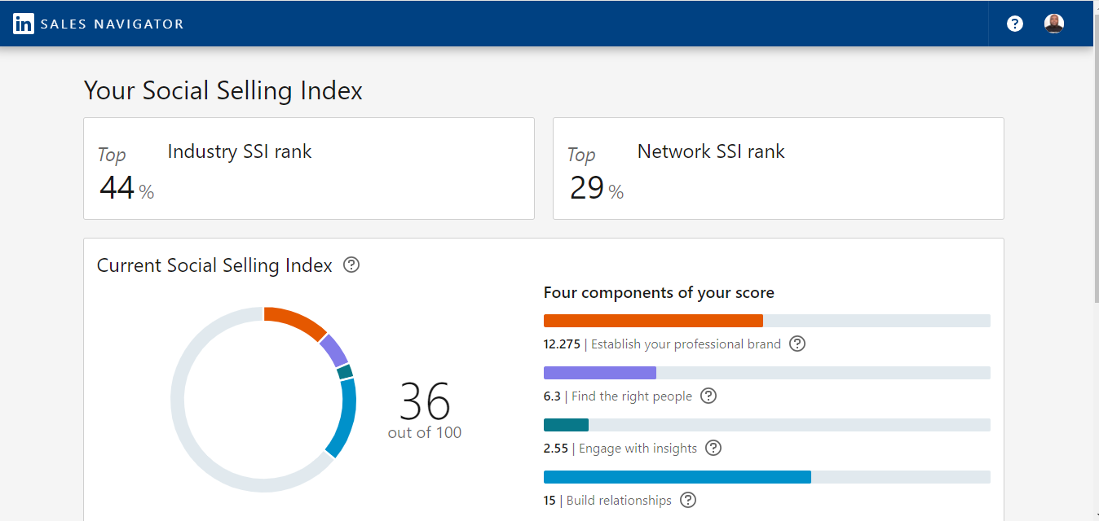

**SSI Score on March 17, 2024**

